CHAPTER – 5

INTERMEDIATE CODE GENERATION

4.1 INTERMEDIATE LANGUAGES

There are three kinds of intermediate representations, they are
1. Syntax trees
2. Postfix notations
3. Three address code

- Syntax trees
- A syntax tree depicts the natural hierarchical structure of a source program.
- A syntax tree for the assignment statement a := b* - c + b* -c is
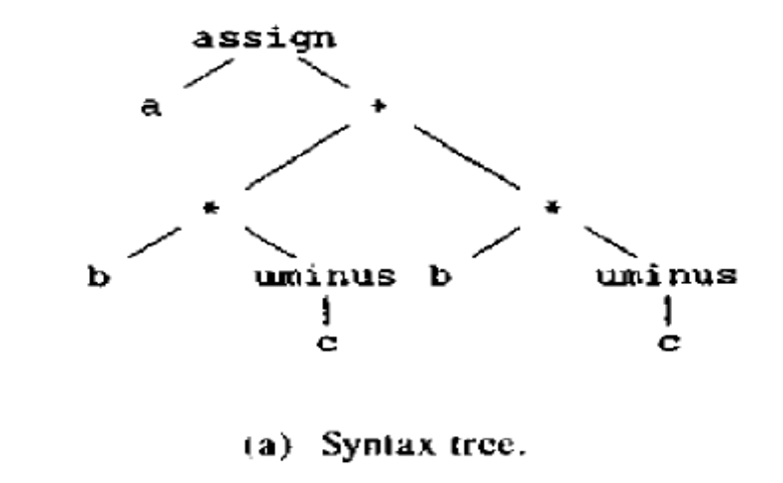

- Postfix notation
- Postfix notation is a linearized representation of a syntax tree, it is a list of the nodes of the tree in which a node appears immediately after its children.
- The postfix notation for the syntax tree is

- Three-Address Code

- Three address code is a sequence of statements of the general form where x, y, and z are names, constants, or compiler-generated temporaries;
- op stands for any operator, such as a fixed or floating-point arithmetic operator, or a logical operator on boolean-valued data.
- The reason for the term "three-address code" is that each statement usually contains three addresses, two for the operands and one for the result.

Example : 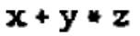
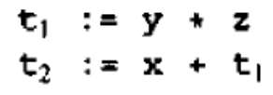

Three address code for the syntax tree a := b* - c + b* -c is
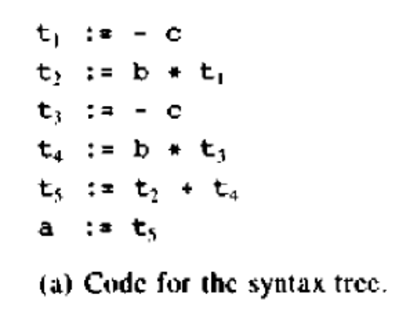

4.2 IMPLEMENTATION OF THREE-ADDRESS STATEMENTS

A three address statement is an abstract form of intermediate code. There are three types of representations:
- Quadruples
- Triples
- Indirect Triples

- Quadruples
- A quadruple is a record structure with four fields, which we call op, arg1, arg2, and result. The op field contains an internal code for the operator.
- The three-address statement x : = y op z is represented by placing y in arg 1, z in arg2, and x in result.
- Statements with unary operators like x : = -y or x : = y do not use arg2.
- Operators like param use neither arg2 nor result.
- Conditional and unconditional jumps put the target labe1 in result.

Quadruple for the statement a := b* - c + b* -c is
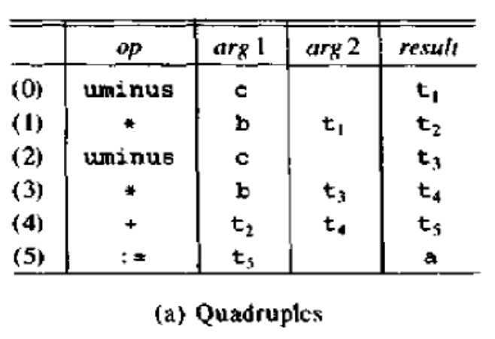

- The contents of fields arg1 , arg2, and result are normally pointers to the symbol-table entries for the names represented by these fields. If so, temporary names must be entered into the symbol table as they are created.
- Triples
- Three-address statements can be represented by records with only three fields: op, arg1 and arg2. Since three fields are used, this intermediate code format is known as triples.
- The field’s arg1 and arg2, for the arguments of op, are either pointers to the symbol table or pointers into the triple structure.
- To avoid entering temporary names into the symbol table. We might refer to a temporary value by the position of the statement that computes it.

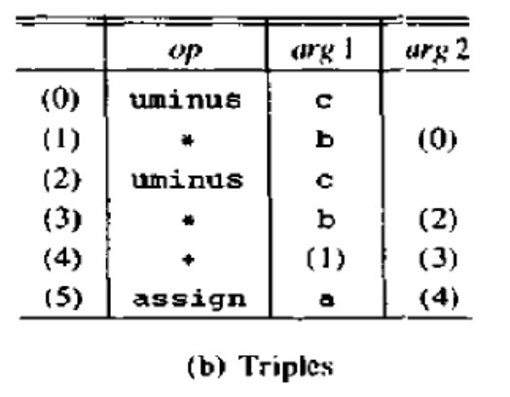
The triple representation of x[ i]: = y
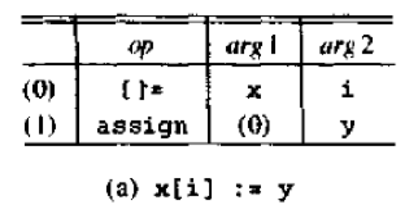
The triple representation of x := y[ I ]
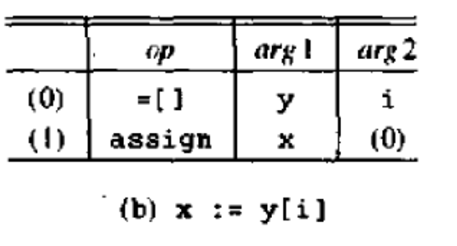
- Indirect triples
Listing pointers to triples rather than listing the tuples themselves are called indirect triples.

Indirect triple representation of a := b* - c + b* -c

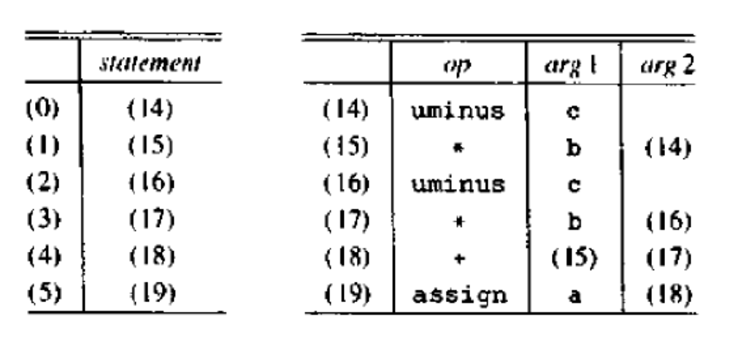
Advantage: Indirect triples can save some space compared with quadruples, if the same temporary value is used more than once.

4.3 ASSIGNMENT STATEMENTS

- Expressions can be of type Integer, real, array, and record.
- Translation scheme to produce three address code for assignments

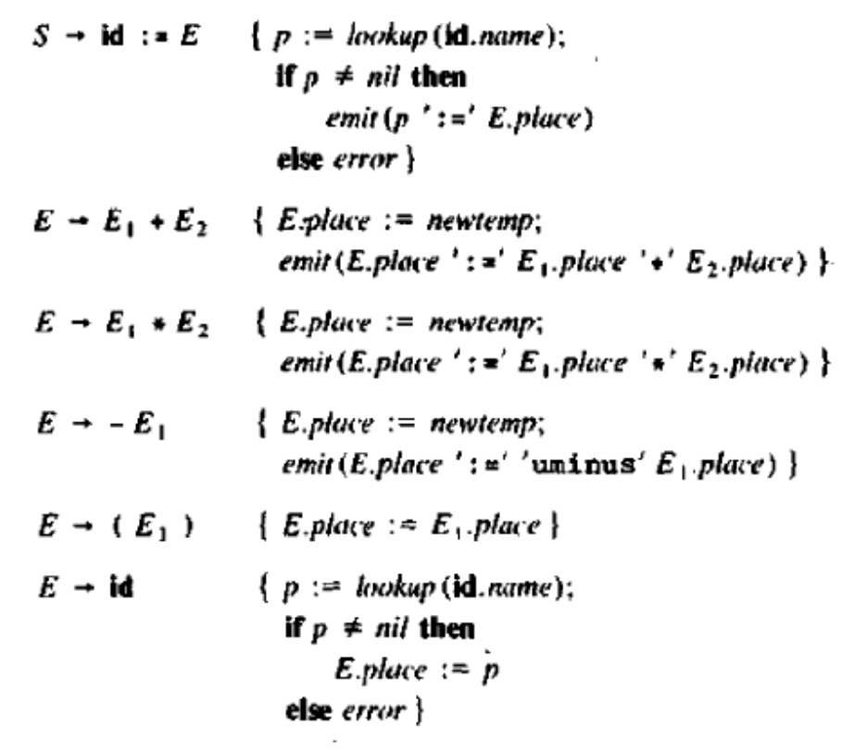
- The translation scheme shows how such symbol-table entries can be found. The lexeme for the name represented by id is given by attribute id.name.
- Operation lookup (id.name) checks if here is an entry for this occurrence of the name in the symbol table. If so, a pointer to the entry is returned; otherwise, lookup returns nil to indicate that no entry was found.
- E.place - the name that will hold the value of E.
- Newtemp generates a new temporary name each time a temporary is needed.
Type Conversions within Assignment
- In practice, there would be many different types of Variables and constants, so the compiler must either reject certain mixed-type operations or generate appropriate type conversion instructions.
- Consider the grammar for assignment statements as above, Assume there are two types - real and integer, with integers converted to real when necessary.
- The semantic rule for E.type associated with the Production E E + E is:
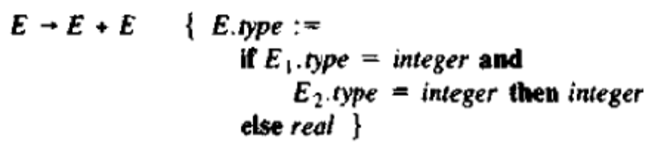
The complete semantic action for a production of the form E E1 + E2 is

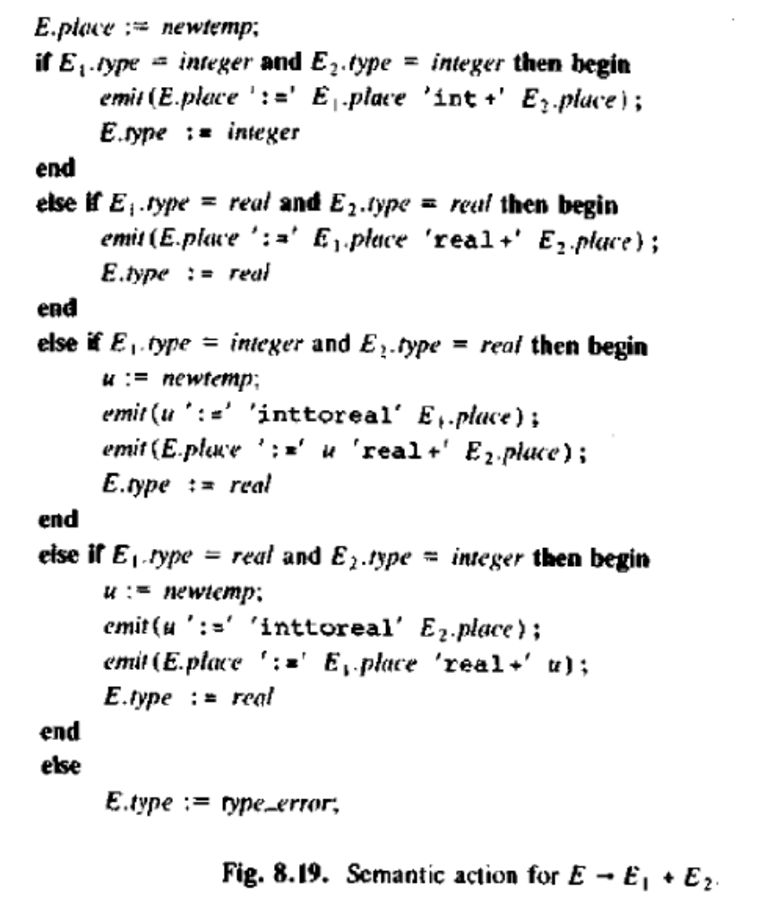

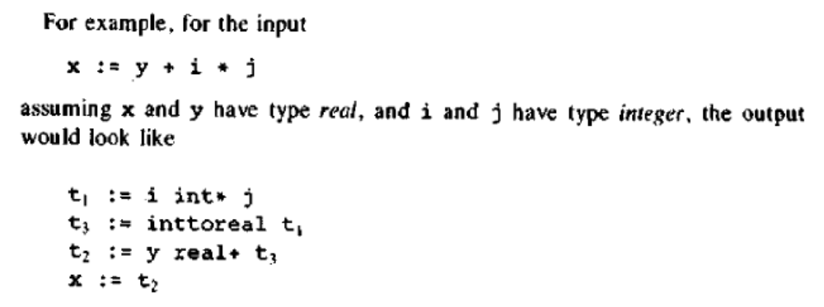

4.4 BOOLEAN EXPRESSIONS

- Boolean expressions are composed of the boolean operators (and, or, and not) applied to elements that are boolean variables or relational expressions.
- In turn, relational expressions are of the form E1 relop E2 , where E1 and E2 are arithmetic expressions.
- In programming languages, boolean expressions have two primary purposes.
- They are used to compute logical values, but more often they are used as conditional expressions in statements that alter the flow of control, such as if then, if-then-else, or while-do statements.
- we consider boolean expressions generated by the following grammar:
Methods of Translating Boolean Expressions
- There are two principal methods of representing the value of a boolean expression. The first method is to encode true and false numerically.
1 is used to denote true and 0 to denote false.
- The second principal method of implementing boolean expressions is by flow of control, that is, representing the value of a boolean expression by a position reached in a program
- For example, given the expression E l or E2, if we determine that E1 is true, then we can conclude that the entire expression is true without having to evaluate E2.

Numerical Representations
Expressions will be evaluated completely, from Left to right, in a manner similar to arithmetic expressions.
For example, the translation for a or b and not c is the three-address sequence

t1 := not c
t2 := b and t1
t3 := a or t2

A relational expression such as a < b is equivalent to the conditional statement if a < b then 1 elsee 0, which can be translated into the three address code sequence
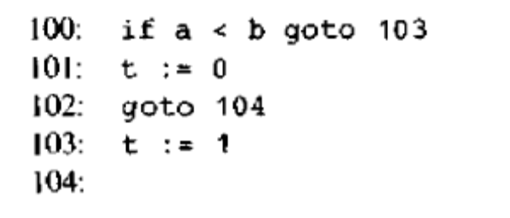
A translation scheme for producing three-address code for boolean expressions is shown in Fig. 8.20.
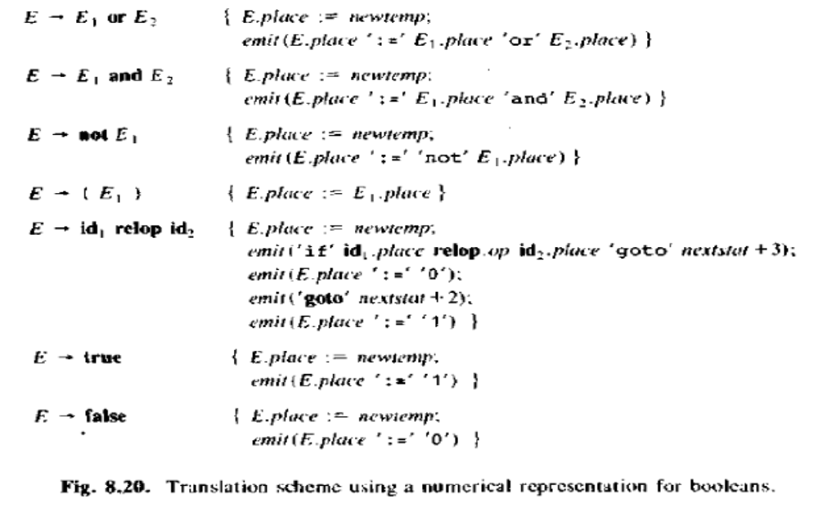
- In this scheme, we assume that emit places three address statement into an output file.
- Nextstat - the index of the next three-address statement in the output sequence.
- Emit - increments nextstat after producing each three-address statement.
Translation scheme for a < b or c < d and e < f
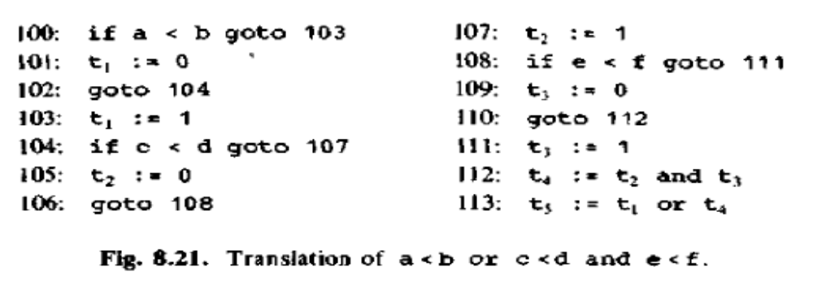
4.5 FLOW OF CONTROL STATEMENT

- The following grammar generates the flow of control statements, if-then, if-then-else, and while-do statements.
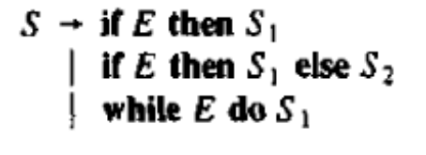
- The Syntax Directed Definition for flow of control statement
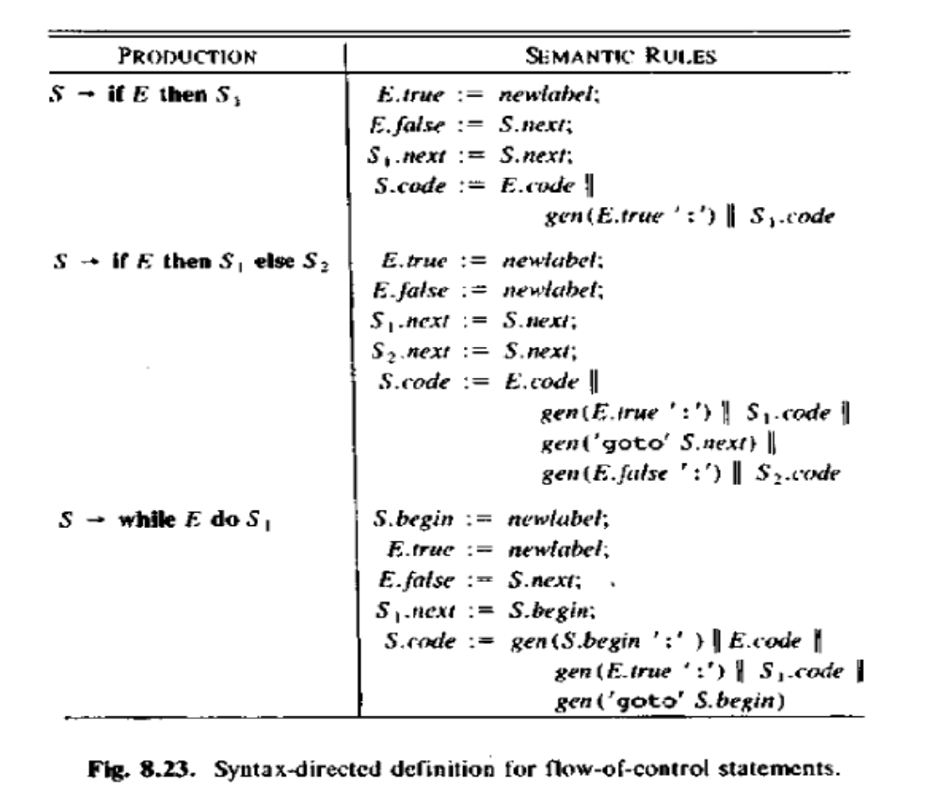
- Newlabel - returns a new symbolic label each time it is called
- E.true - the labe1 to which control flows if E is true
- E.false - the label to which control flows if E is false
- S.next - a label that is attached to the first three address instruction to be executed after the code for s.

If-Then
- In translating the if-then statement S if E then S1, a new label E.true is created and attached to the first three-address instruction generated for the statement as in Fig, 8.22(a).
- The code for E generates a jump to E.true if E is true and a jump to S.next if E is false. We therefore set E.false to S.next.
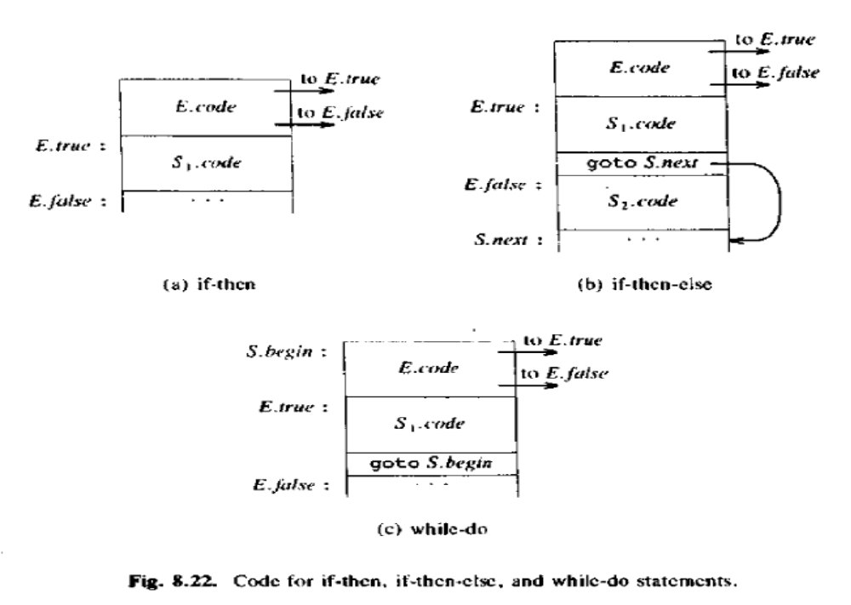
If-then-else
- In translating the if-then-else statement S if E then S1 else S2. the code for the boolean expression E has jumps out of it to the first instruction of the code for S1 if E is true, and to the first instruction of the code for S2 if E is false, as illustrated in Fig. 8.22(b).

While - do statement
- In translating Swhile E do S1, A new label S.begin is created and attached to the first instruction generated for E. Another new label E.true is attached to the first instruction for S1.
- The code for E generates a jump to this label if E is true, a jump to S.next if E is false and set E.false to be S.next. After the code for S1 we place the instruction goto S.begin, which causes a jump back to the beginning of the code for the boolean expression,
Example
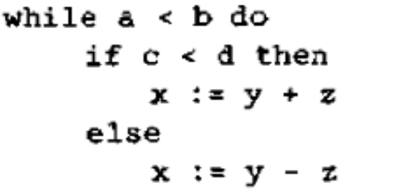
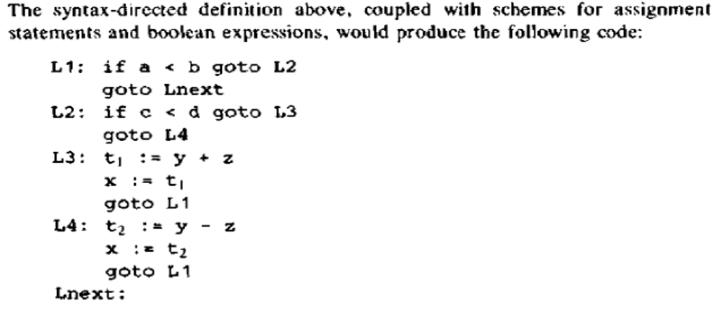

4.6 CASE STATEMENTS

- The "switch" or "case" statement is available in a variety of languages.
- Switch-statement syntax is shown in Fig.
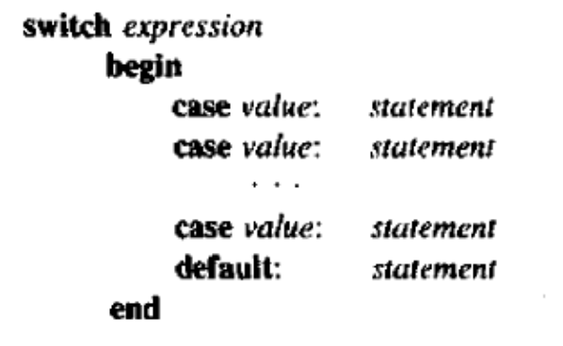
The intended translation of a switch is code to:
1. Evaluate the expression.
2. Find which value in the list of cases is the same as the value of the expression. Recall that the default value matches the expression if none of the values explicitly mentioned in cases does.
3. Execute the statement associated with the value found.

Syntax-Directed Translation of Case Statements
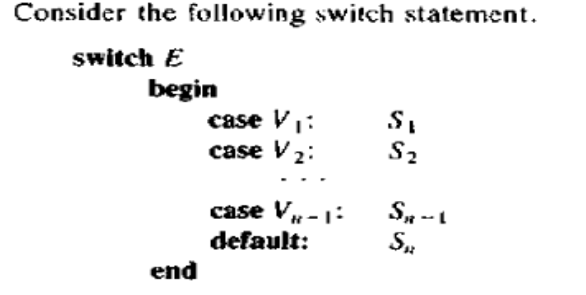

Translation of case statements
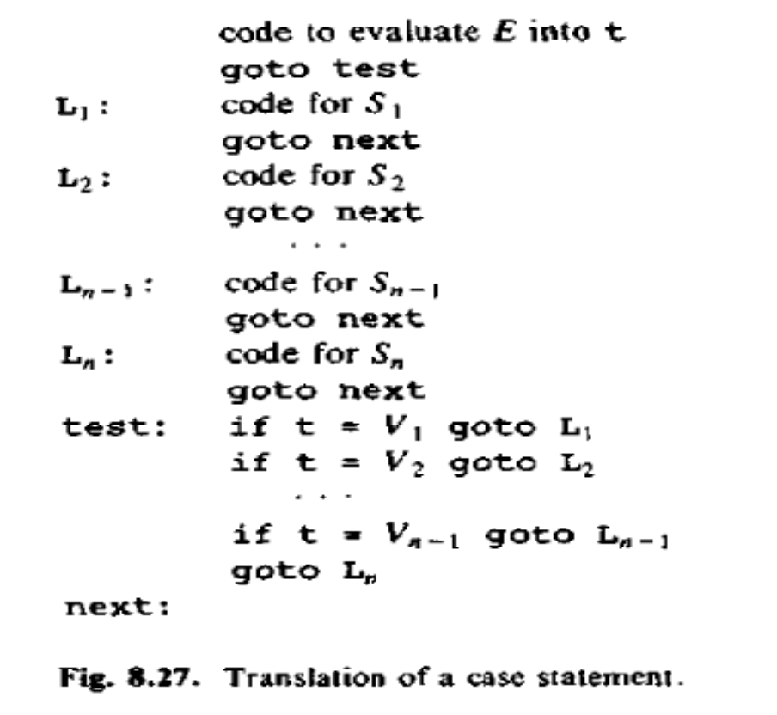
To translate into the form of Fig. 8.27, when we see the keyword switch, we generate two new labels test, next and a new temporary t. Then as we parse the expression E, we
generate code to evaluate E into t. After processing E, we generate the jump goto test.

Then as we see each case keyword, we create a new label Li and enter it into the symbol table. We place on a stack, used only to store cases, a pointer to this symbol-table entry and the value Vi of the case constant.

We process each statement case Vi : Si by emitting the newly created label Li, followed by the code for Si, followed by the jump goto next. Then when the keyword end terminating the body of the switch is found, we are ready to generate the code for the n-way branch.

BACKPATCHING

- Back patching is a technique to solve the problem of replacing symbolic names into goto statements by the actual target addresses.
- This problem comes up because if some languages do not allow symbolic names in the branches.
- Backpatching can be used to do generate code for Boolean expression and control statements in one pass.
- During one pass, the following steps are executed
- Construct the syntax tree.
- Generate jumps with unspecified targets.
- Keep a list of such statements.
- Subsequently fill in the labels.

backpatch(p, i ) - inserts i as the target label for each of the statements on the list pointed to by p.

Example:
Consider the expression a <b or c <d and e< f .
The six statements generated so far are thus:
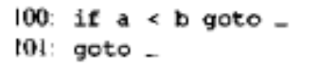
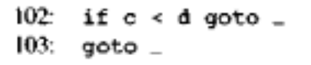
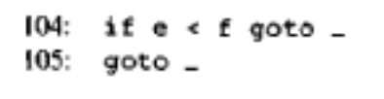
The corresponding semantic action calls Backpatch ({102), 104) where (102) as argument denotes a pointer to the list containing only 402, that list being the one pointed to by E1.truetist. This call to backpatch fills in 104 in statement 102. The six statements generated so far are thus:
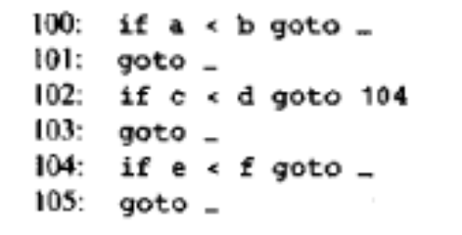

SYMBOL TABLE
A compiler uses a symbol table to keep track of scope and binding information about names. The symbol table is searched every time a name is encountered in the source text. Changes to the table occur if a new name or new information about an existing name is discovered.
A symbol-table mechanism must allow us to add new entries and find existing entries efficiently. The two symbol-table mechanism presented in this section are linear lists and hash tables.
A linear list is the simplest to implement. but its performance is poor when the number of entries are large.
Hashing schemes provide better performance for somewhat greater programming effort and space overhead.
Symbol-Table Entries
Each entry in the symbol table is for the declaration of a name, The format of entries does not have to be uniform, because the information saved about a name depends on the usage of the name.
Each entry can be implemented as a record consisting of a sequence of consecutive words of memory. To keep symbol-table records uniform, it may be convenient for some of the information about a name to be kept outside the table entry, with only a pointer to this information stored in the record.
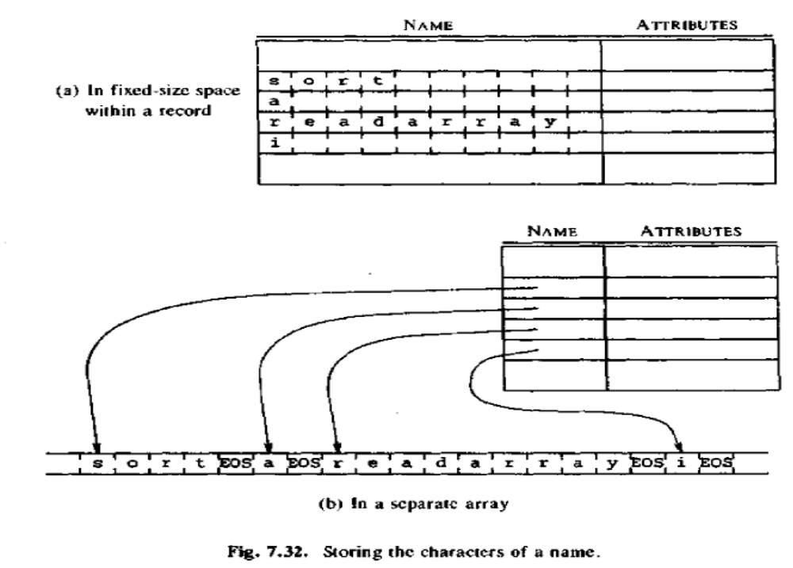

If there is a modest upper bound on the length of a name, then the characters in the name can be stored in the symbol-table entry, as in Fig. 7.32(a).
If there is no limit on the length of a name, or if the limit is rarely reached, the indirect scheme of Fig. 7.32(b) can be used.

The data structures used for implementing the symbol table are:
1. Linear list
2. Hash table

- Linear list
- The simplest and easiest to implement data structure for a symbol table is a linear list of records. New names are added to the list in the order in which they are encountered.
- The position of the end of the array is marked by the pointer available.
- The search for a name proceeds backwards from the end of the array to the beginning. When the name is located, the associated information can be found in the words following next.
- If we reach the beginning of the array without finding the name, a fault occurs - an expected name is not in the table.

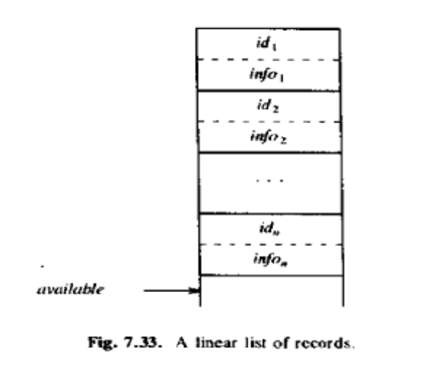

The average search for the name in the symbol table is N/2 comparisons.

Advantage
It takes less space.
Insertion to the table is simple.

- Hash Tables
The basic hashing scheme consists of two parts
- A hash table consisting of a fixed array of m pointers to table entries.
- Table entries organized into m separate linked lists, called buckets. Each record in the symbol table appears on exactly one of these lists.

  0
  1
  .
  .
  .
  m
  Name | Info
  Name | Info
  Name | Info
Hash Table

To enter a name into symbol table, we find out the hash value of the name by applying suitable hash function, which maps the name into an integer between 0 to m-1, and using the value generated by a hash function as index in a hash table, we search the list of the symbol table records built on that hash index, if the name is not present in that list we create a record for name and insert it at the head of the list built on that hash index.

The retrieval of the information associated with the name is done as follows.
- First, the hash value of the name is obtained and the list button on this hash value is searched for getting the information about the name.

